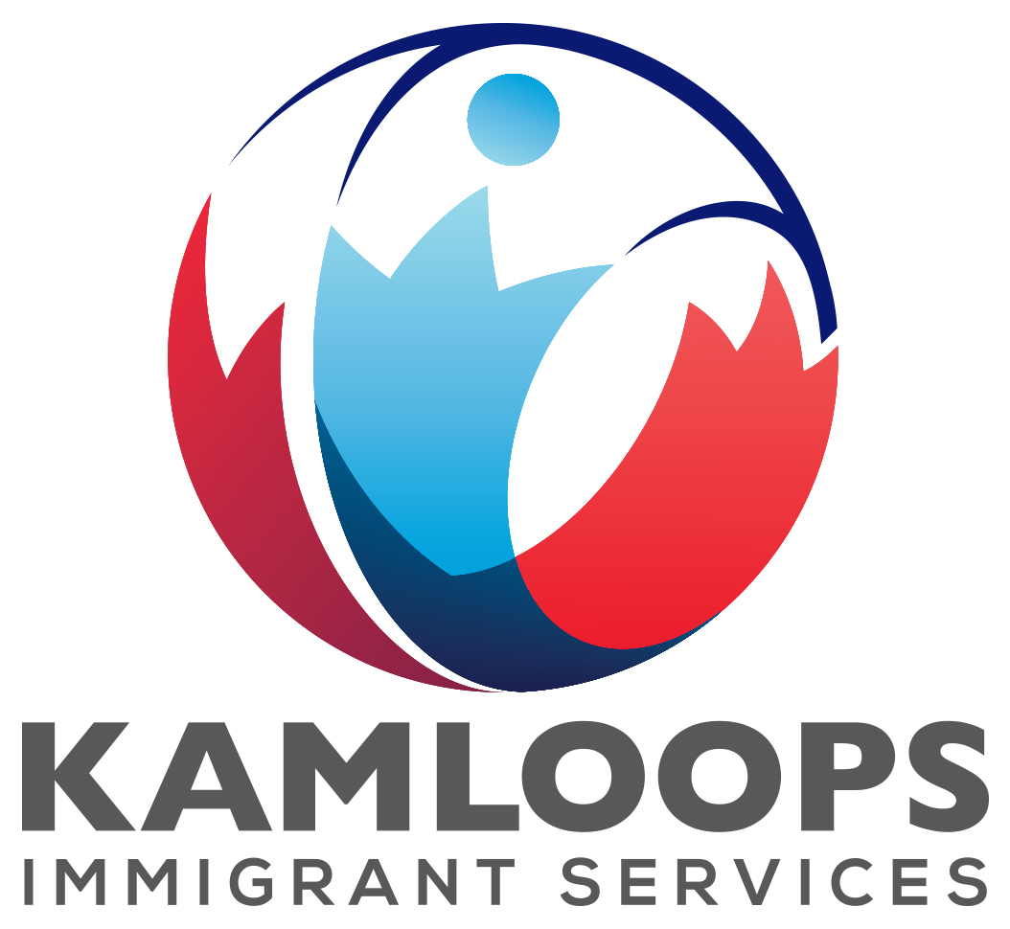
448 Tranquille Road, Kamloops, BC V2B 3H2
Phone: 778-470-6101 Fax: 778-470-6102
communityconnection@kcris.ca
www.kamloopsimmigrantservices.ca

Volunteer Guide
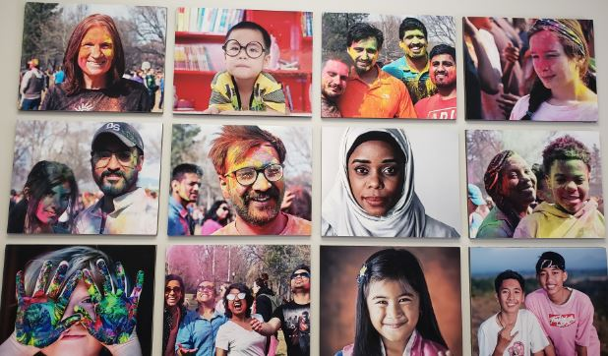

Sponsored by:
Kamloops-Cariboo Regional Immigrants Society

Revised December 2022

Table of Contents

Introduction 1
Organizational Structure….…………………………………………………………………………………………………………2
Mission and Values ……………………………………………..…………………………………………………………………….3
Our Programs & Services 3
Volunteer Opportunities at Kamloops Immigrant Services 7
General Guidelines 11
Qualities of a Good Volunteer 12
Responsibilities of a Volunteer……………………………………………………………..………………………………….13
Policies of Kamloops Immigrant Services 14
Legal Responsibilities of the Volunteer 15

Introduction

“Volunteering is fundamental to a healthy and democratic society; all citizens have a right and a responsibility to contribute in the manner that works for them” The Canadian Code for volunteer involvement

As Newcomers you may be looking to volunteering as a way to contribute and integrate into your new community, develop skills, and gain Canadian experience.

As Canadians you may be looking to volunteering as a way to strengthen your ties to the community, exposing you to people with common interests, neighbourhood resources, and fun and fulfilling activities.

We are thankful for the opportunity to develop with you a reciprocal relationship where your goals and the agency’s mission are considered in a mutual approach to building community.

We have compiled information and guidelines to help you succeed as a KIS volunteer.

We look forward to growing with you.

Page 1

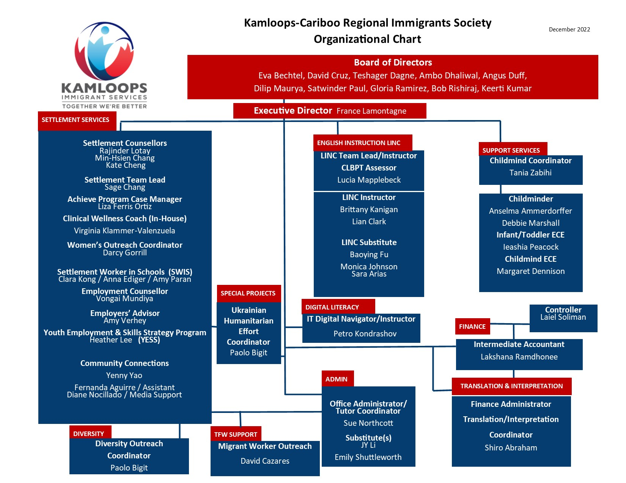

Page 2

Mission and Values

Kamloops-Cariboo Regional Immigrants Society is a not for profit, registered society and registered charity. Programs and services are delivered through an agency “Kamloops Immigrant Services.”

Mission
- To deliver a broad range of programs which are sensitive to the needs of the culturally diverse community.
- To deliver programs and activities designed to facilitate immigrants, visible minorities, first generation Canadians and their families in becoming full and equal members of Canadian society.
- To inform and sensitize the region on immigration, settlement, integration, and multicultural issues.
- To promote the elimination of racism and to facilitate organizational and institutional change.
- To provide assistance necessary for immigrants, visible minorities and first generation Canadians
and their families to become full and equal members of Canadian society.
- To facilitate organizational and institutional change to meet the needs of a culturally diverse society.

Values
Kamloops-Cariboo Regional Immigrants Society operates according to the following core values:
- Excellence in service delivery
- Mutual respect
- Inclusiveness
- Collaboration
- Harmony
- Diversity
- Honesty
- Integrity
- Equity

Page 3

Our Programs & Services

Our Programs
- Settlement Services
- English Language Instruction
- Employment-Readiness Services
- Settlement Workers in Schools
- Orientation clinics and classes
- Life Skills workshops
- Wellness activities
- Diversity and outreach
- Youth program
- ESL Tutoring
- Mentoring
- Translation and Interpretation
Settlement Services
- Needs Assessment
- Information and Orientation
- Referrals to service providers
- Connections to government programs
- Advocacy
- Citizenship preparation
- Multilingual staff – 14 languages
- Community connections
Support Services
- Free childminding on-site while eligible clients access KIS services
- Translation and Interpretation (fee for service, more than 40 languages available)
- Crisis Counselling
Page 4

Intercultural Employment Settlement Program
- Skills development
- Job search and local resources
- Employment needs assessment
- Job search & job readiness coaching
- Job leads and employment opportunities
- Entrepreneur support and resources
- Referrals
- Workplace culture
- Skills development and training support
Settlement Workers in Schools (SWIS)
- Connecting immigrant refugee students and families to school, community, government resources including access to recreation for low income families
- School registration and orientation Elementary and Secondary Students
- Understanding school policies and procedures
- Communicating with teachers and administrators
- Parent-Teacher interview support
- Workshops and information sessions (Parenting in Canada, Lunch Box Nutrition)
- Consultation on school transition
- Advocating for newcomer students and families
Community Connections
- Social, cultural and professional interactions
- Citizenship 101 study
- Learn to camp; learn to fish
- Blazers hockey games
- Local community events and field trips
- French 101
- Mentorship program

Page 5

Community Connections continued
- Life skills workshops
- Family sports
- Hiking, yoga, gardening, cooking
- More activities available
Language Instruction for Newcomers to Canada (LINC)
- Free English classes (Literacy to CLB 8) for eligible clients
- Flexible schedule: morning, afternoon and evening classes
- Small groups, great atmosphere
- Focus on life in Canada, employment, including field studies
- Certified Canadian Language Benchmark Placement Test (CLBPT)
- Seats available for non-eligible clients for a fee
Diversity
- Promotes a welcoming community through workshops, events and activities
- Presentations in schools and organizations
- Promotion of Multiculturalism
- Community events and field trips
- Collaboration with local agencies
- Weekly “Community Connection” activities

Page 6

Volunteer Opportunities at

Kamloops Immigrant Services

Childmind Support

Description: Help our experienced childminders care for newcomer children, to allow their parents to attend our classes and events.

Duties: - Assist with the preparation of snacks, arts/crafts, indoor & outdoor activities.
- Assist children with arts/crafts, mealtimes, games & activities.
- Respect & follow the guidance of the Childmind Coordinator, childminding
guidance policies and the confidentiality agreement.
- Regular scheduled attendance.

Prerequisites: Gain experience working with children! We welcome responsible adults, certified
ECE (Early Childhood Education) Assistants and/or individuals with or working
towards a full ECE certification. You will gain experience working with children under the guidance of an Early Childhood Educator. We are looking for an individual who is committed to support children to achieve their development goals.
Translator/Interpreter

Description: Support newcomers the general public while using your communication and language skills! We coordinate an Interpretation and Translation Service, provided through a network of volunteers and professionals. Translation involves working with documents in different languages. These often need to be notarized as well. Interpretation involves verbal skills, helping people with different languages understand each other. Volunteers are needed to translate (written) and interpret (oral) for clients and for other organizations (i.e. hospital, court, R.C.M.P.).

Duties: - To interpret and translate accurately
- To respect and abide by strict rules of confidentiality
- To remain impartial and have the capacity to be passively receptive.
- To attend all relevant training sessions

Prerequisites: This person must be bilingual and bicultural and must have a good understanding of the Canadian system. Volunteers must undergo orientation.

Page 7
E.S.L. Tutors

Description: Provide extra support for a newcomer as they work towards their goal of English language acquisition. Gain experience as a tutor while assisting immigrants to improve their English skills and learn more about Canada by establishing a link with a volunteer within the community! Volunteers are placed according to their previous experience and interest in learners who are unable to attend regular LINC (Language Instruction for newcomers to Canada) classes or who have special learning needs. Assist newcomers with improving their English language skills in an informal environment, working on a one-on-one basis with individuals with diverse language skills levels.

Duties: - Provide one-on-one support and English language instruction

Prerequisites: Experience teaching, TESL certificate, excellent English language skills, patience, and non-judgemental attitude.
Chinese English Learning Group

Description: Encourage a group of newcomers who speak Chinese and want to practice speaking English in the weekly bilingual group. Topic lessons will be provided by bilingual volunteers each week.

Duties: - Ensure all participants get a chance to practice speaking
- Ensure prepare lessons with topics
- Explain difficult vocabulary, expressions, and grammar
- Promote an inclusive, respectful environment

Prerequisites: Previous teaching experience is preferred. Excellent English language skills, personable, non-judgemental.
Community Connections Mentorship

Description: The mentorship Program matches newcomers to Canada with a volunteer who is familiar with Kamloops to meet once per week. This is a fun, friendship-based program, and is very rewarding for both participants and volunteers. You are welcome to share skills, hobbies, knowledge, and time with newcomers helping them adjust to life in Kamloops by teaching them about Canadian culture and lifestyle, skills, community resources, and how to connect with local people and improve their English and achieve their goals. You will be matched with a newcomer based on shared interests.

Duties: - Take the initiative in contacting your match
- Meet weekly at a place/time that is mutually agreeable
- Respect and abide by strict rules of confidentiality

Page 8

Community Connections Mentorship continued

Prerequisites: This person must be very familiar with Kamloops and Canadian culture. This volunteer must also be open to learning about new cultures, patient and understanding, non-judgemental.

Computer Mentors

Description: Share your computer skills with small groups of newcomers looking for help with basic skills. For some participants, learning to use e-mail and social media can help them connect with family and friends, while for others learning MS Office and Excel can be the key to helping them find employment.

Duties: - Attend weekly 1 hour sessions
- Instruct 1-3 newcomers on basic computer functions, based on their needs

Prerequisites: Must have good computer skills and an interest in teaching. Must be patient and able to give clear instructions.

Workshop and Program Facilitators

Description: Help newcomers to Canada settle into our community by sharing your skills with them! Whether you are a yoga instructor who wants to give back, or a history buff who can help teach Citizenship, or passion about teaching yoga, gardening, you are welcome to pitch us your programming ideas! We are always looking for experts who can share their professional knowledge and skills with newcomers to live a healthy lifestyle through workshops and presentations. For example law, medical, therapy, dental and nutrition workshop.

Duties: - Meet with Community Connections Coordinator to discuss your programming idea
- Share your expertise on a particular topic. This can be a weekly recurring program, or a one-time event.

Prerequisites: Must be qualified to teach or instruct on the topic at hand – requirements for this will vary. Must have the ability to teach in a respectful, non-judgemental manner. Experience working with diverse groups is an asset.

Page 9

Special Events Assistants

Description: Volunteers are needed to provide support for a variety of events. Come early and help us set up the room, then welcome the participants as they arrive. Join in the event and then help us clean up when it’s done!

Prerequisites: All you need is to be a good team player! This is a great volunteer opportunity for those who are still learning English.

Sports Coach

Description: Coach volunteers guide newcomers to learn different sport skill and provide a fun experience in a safe environment. Examples: soccer, badminton, pickleball, etc.

Duties: - Plan, implement and evaluate developmentally appropriate activities with supporting weekly lesson plans that are creative, flexible and adaptable. Provide a safe, positive and well-managed learning environment.
- Ensure appropriate set up, take down and maintenance of program space
- Communicate with other and volunteers.
- Provide evaluation and feedback to supervisor regarding program content

Prerequisites: Previous coaching experience is preferred. Excellent English language skills, personable, non-judgemental.

French teacher volunteers

Description: Guide a group of newcomers who are interested in learning basic French. Class will be on Zoom.

Duties: - volunteer make a lesson plan
- Ensure all participants get a chance to participate

Prerequisites: Previous teaching experience is preferred. Excellent English and French language skills, personable, non-judgemental.

Page 10

General Guidelines

Things Not To Do/Say as a Volunteer

- Give advice…“you should…”
- Ridicule or put down clients…“can’t you get the answer…?”
- Respond in a judgmental way; develop a non-accepting climate.
- Express sympathy or feel sorry for the client…“that must be so, so awful; oh you poor thing….”
- Ask irrelevant questions, ask questions about the client’s personal life.
- Interrupt or dominate the interaction.
- Talk about self instead of focusing on the concern for the client or respond to something other than what he/she may be saying.
- Talk down to the client.

Things to Do/Say as a Volunteer

- Listen by demonstrating attending behaviour: eye contact, “yes,” nodding.
- Show faith in the ability of the client to solve the lesson, giving time for them to answer the question(s).
- Show caring, understanding, support, and acceptance.
- Ask questions which are directly related to the conversation or client’s lesson.
- Offer relevant information.
- Speak clearly in a normal tone of voice and as close to a normal pace as possible; but if you notice that the client is not understanding, then speak more slowly.
- If the client does not understand try to say it differently; do not keep repeating the same message.
- Use diagrams and drawing (if possible) to help the client to understand.

Page 11

Qualities of a Good Volunteer

- An enthusiastic desire to work with or for immigrants, visible minority Canadians, or new Canadians.
- A sense of humor.
- Positive behaviour and attitude.
- Patience.
- Outgoing personality.
- Emotional maturity.
- Leadership abilities.
- Acceptance of responsibilities.
- Flexibility yet firmness in providing guidance.
- Sets a good example.
- Reliable and punctual.
- Well prepared.
- Co-operative and accepting of directions from the staff.
- Willingness to grow and learn as a person.

Page 12
Responsibilities of a Volunteer

Commitment
In order for the services of Kamloops Immigrant Services to be successful, it is essential for volunteers to be reliable and dependable. Once you have made a promise to be available, please live up to your words.

Completion of services
It is the responsibility of the volunteer to notify the Volunteer Coordinator if he or she will no longer be available to volunteer at the agency.

Change of Contact Information
It is the responsibility of the volunteer to notify the Volunteer Coordinator of any changes in address or phone number.

Representative of Kamloops Immigrant Services
Volunteers must be aware that they are a representative of Kamloops Immigrant Services and will be viewed as such by the clients and public.

Providing Information
It is essential that volunteers only give accurate information to clients. If a client is requesting information then the volunteer must refer the client to one of the Settlement Counsellors at Kamloops Immigrant Services who have access to all current and accurate information.

Page 13

Policies at Kamloops Immigrant Services

Confidentiality
Maintaining confidentiality is one of the most important responsibilities. Information concerning the clientele, staff, and volunteers at Kamloops Immigrant Services must be confidential. If there is information which you feel must be shared, do so only with the appropriate staff member of Kamloops Immigrant Services.

Use of Name of the Organization
Individuals should only speak on behalf of the agency if they have been asked to by the Board of Directors or the Executive Director. In all other situations, volunteers should make it clear that they are speaking for themselves.

Political Affiliation
Kamloops Immigrant Services is a non-partisan organization; therefore, volunteers should not associate the agency to any particular political member or organization without the permission of the Board of Directors or the Executive Director.

Religious and Cultural Affiliation
Kamloops Immigrant Services treats each and every individual with the utmost respect regardless of culture, religion, or race. Thus, volunteers should not associate the agency to any particular religion or culture organization without the permission of the Board of Directors or Executive Director.

Use of Resources
Resources of Kamloops Immigrant Services are not to be used for any reason or business purpose that is not directly related to the agency. This includes the equipment and space owned by the agency.

Acceptance of Gifts
The acceptance of gifts is discouraged by Kamloops Immigrant Services. If a client wishes to express his or her gratitude, he or she should donate to the agency.

K.I.S. Responsibility
As a volunteer at Kamloops Immigrant Services, you have the right to be safe, to be treated with respect and dignity by staff and clients, to access all of Kamloops Immigrant Services’ resources as required by your volunteer duties and to receive an appropriate orientation to the agency, its policies, and procedures.
Page 14

Legal Responsibilities of the Volunteer

Duty of Care
A duty of care is the responsibility to avoid careless injury; it may also include a responsibility to warn of a hazard.

Volunteers are not employees; therefore, duty of care is likely to proceed from the neighbourhood principle: I owe a duty of care to anyone who may be injured by my action, providing such injury is reasonably foreseen.

For example, the volunteer owes a duty of care to the children under his care because it is reasonably foreseen that they could be closely and directly affected by the volunteers’ action.

Any careless action taken by a volunteer will result in automatic dismissal from the activities at Kamloops Immigrant Services.

Duty of Privacy
Volunteers engaged in activities at Kamloops Immigrant Services acquire information on the understanding that it will remain confidential. Failure to maintain confidentiality will result in an automatic dismissal from any activities at Kamloops Immigrant Services.

Volunteer Driving and Insurance
Volunteers engaged in driving at any charitable organization (such as Kamloops Immigrant Services) do not need to amend their existing vehicle insurance rate if they are not receiving any form of compensation or wage for their services.

Page 15

